HTML and HTML Editors TEC 236 2/20/06

In computing, 'HyperText Markup Language ' (HTML) is a markup language designed for the creation of web pages with hypertext and other information to be displayed in a web browser. HTML is used to structure information — denoting certain text as headings, paragraphs, lists and so on — and can be used to describe, to some degree, the appearance and semantics of a document.

Originally defined by Tim Berners-Lee and further developed by the IETF with a simplified SGML syntax, HTML is now an international standard (ISO/IEC 15445:2000). Later HTML specifications are maintained by the World Wide Web Consortium (W3C).

Early versions of HTML were defined with looser syntactic rules which helped its adoption by those unfamiliar with web publishing. Web browsers commonly made assumptions about intent and proceeded with rendering of the page. Over time, the trend in the official standards has been to create an increasingly strict language syntax; however, browsers still continue to render pages that are far from valid HTML.

A piece of HTML code with syntax coloring

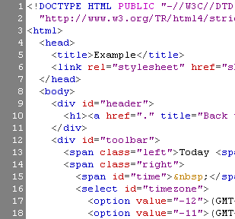

Install Dreamweaver MX form CD

Instructor will lead the following:

Open DW (Dreamweaver MX)

Click Site > New Site
Will point to c:\my-ftp

Open IIS Administration ( we will be using the Default Web Site and FTP site for our Web Site development, the virtual sites were for practice)
Add index.html to Default Web Site > Documents, move to top of list
Setup Default FTP Site to point to c:\inetpub\wwwroot
Add write permission
Check other tabs and allow anonymous

Open up DW
Open the index.html page from c:\my-ftp– change link – bold – font size – save
Add page title
Open the second.html page from c:\my-ftp– change link – bold – font size – save
Add page title

Open WS_FTP
Change startup
Local Folder – c:\my-ftp
Transfer index.html and second.html to wwwroot (Web Server)
Create an images folder on the local and remote

Open I.E and test using localhost or your IP
Check links, page title

Download Web Site Image from planetlinks.com/tec236 to your temp folder (may need to create)

Unzip to c:\my-ftp\images\

Using WS_FTP transfer all images to the images folder on the web server

