JavaScript Programming TEC 236 3/1/06

Create a Small Animal Toys & Accessories Table Page

In DW open up your template.html file

If needed clear out the center table

Save as small-animal-toys.html

If needed, add banner, background, link up buttons

Add page title
Modify > Page Properties

Add a table to the center of the page
Place cursor where you want the table to go
Insert > Table
Rows: 7
Columns: 5
Width: Leave blank
Border: 1

Adjust table

Add headers to the first row:
Photograph | Product Title | Unit Price | Orders | Description

Add images to the first column (use your alt tags)
toyhouse.jpg
hamsterwheel.jpg
giantball.jpg
ferret-playhouse.jpg
minimanor.jpg
kit.jpg

From image below add:
Text in column 2
Add price in column 3
Leave column 4 empty for now
Add description to column 5

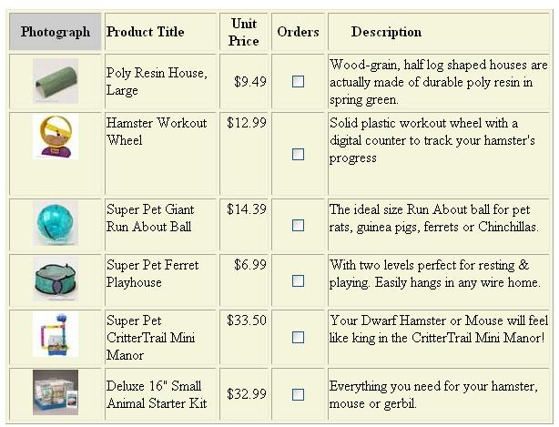

Create a Form

Place your cursor above your table

Insert Form (will give you a dotted line outline of the form location

High-light your table
Cut it and paste it into the form outline

Add Check Boxes to Column 4

CheckBox 1
Place your cursor in the 2nd row 4th column

CheckBox 1
Add a checkbox Insert > Form Objects > Check Box

Set the Properties for the Check Box (should be a check box property sheet at the bottom of your DW workspace)

Checkbox : item1
Checked Value: 9.49
Initial State: Unchecked

CheckBox 2
Place your cursor in the 3rd row 4th column

Add a checkbox Insert > Form Objects > Check Box

Set the Properties for the Check Box (should be a check box property sheet at the bottom of your DW workspace)

Checkbox : item2
Checked Value: 12.99
Initial State: Unchecked

CheckBox 3
Place your cursor in the 4th row 4th column

Add a checkbox Insert > Form Objects > Check Box

Set the Properties for the Check Box (should be a check box property sheet at the bottom of your DW workspace)

Checkbox : item3
Checked Value: 14.39
Initial State: Unchecked

CheckBox 4
Place your cursor in the 5th row 4th column

Add a checkbox Insert > Form Objects > Check Box

Set the Properties for the Check Box (should be a check box property sheet at the bottom of your DW workspace)

Checkbox : item4
Checked Value: 6.99
Initial State: Unchecked

CheckBox 5
Place your cursor in the 6th row 4th column

Add a checkbox Insert > Form Objects > Check Box

Set the Properties for the Check Box (should be a check box property sheet at the bottom of your DW workspace)

Checkbox : item5
Checked Value: 33.50
Initial State: Unchecked

CheckBox 6
Place your cursor in the 7th row 4th column

Add a checkbox Insert > Form Objects > Check Box

Set the Properties for the Check Box (should be a check box property sheet at the bottom of your DW workspace)

Checkbox : item6
Checked Value: 32.99
Initial State: Unchecked

Add a textbox for the total
Directly under the products table type:
Total Cost = $

Insert > Form Object > Text Field

Set the Properties
TextField: total_cost
You can leave the rest of the properties to the defaults

Save the page

Add Java Script (JS) Code

In DW View > Code

In your HTML code find the </head> tag (should be near the top)

After the </head> tag add the following JS Code

<script>

function compute()
{
if (document.forms.item1.checked)
{
var item1=(9.49)
}
else
{
var item1=(0);
}
if (document.forms.item2.checked)
{
var item2=(12.99)
}
else
{
var item2=(0);
}
if (document.forms.item3.checked)
{
var item3=(14.39)
}
else
{
var item3=(0);
}
if (document.forms.item4.checked)
{
var item4=(6.99)
}
else
{
var item4=(0);
}
if (document.forms.item5.checked)
{
var item5=(33.50)
}
else
{
var item5=(0);
}
if (document.forms.item6.checked)
{
var item6=(32.99)
}
else
{
var item6=(0);
}

var Total_Cost=(item1 + item2 + item3 + item4 + item5 + item6);
document.forms.Total_Cost.value=Total_Cost.toFixed(2);
}
</script>

Save the Page

Add Code To Check Boxes

1) In DW design view View > Design click on check box 1

Switch to code view View > Code

Find (should be high-lighted)

<input name="item1" type="checkbox" id="item1" value="9.49">

Add onClick="compute()"

So the line looks like

<input name="item1" type="checkbox" id="item12" value="9.49" onClick="compute()">

2) In DW design view View > Design click on check box 2

Switch to code view View > Code

Find (should be high-lighted)
<input name="item2" type="checkbox" id="item2" value="12.99">

Add onClick="compute()"

So the line looks like

<input name="item2" type="checkbox" id="item2" value="12.99" onClick="compute()">

3) In DW design view View > Design click on check box 3

Switch to code view View > Code

Find (should be high-lighted)

<input name="item3" type="checkbox" id="item3" value="14.39">

Add onClick="compute()"

So the line looks like

<input name="item3" type="checkbox" id="item3" value="14.39" onClick="compute()">

4) In DW design view View > Design click on check box 4

Switch to code view View > Code

Find (should be high-lighted)

<input name="item4" type="checkbox" id="item3" value="6.99">

Add onClick="compute()"

So the line looks like

<input name="item4" type="checkbox" id="item4" value="6.99" onClick="compute()">

5) In DW design view View > Design click on check box 5

Switch to code view View > Code

Find (should be high-lighted)

<input name="item4" type="checkbox" id="item5" value="33.50">

Add onClick="compute()"

So the line looks like

<input name="item5" type="checkbox" id="item5" value="33.50" onClick="compute()">

6) In DW design view View > Design click on check box 6

Switch to code view View > Code

Find (should be high-lighted)

<input name="item6" type="checkbox" id="item6" value="32.99">

Add onClick="compute()"

So the line looks like

<input name="item6" type="checkbox" id="item6" value="32.99" onClick="compute()">

Save the Page

Test the page using IE

http://localhost/small-animal-toys.html

When you check a box it should keep a running total

