Midterm Review TEC 236 3/8/06

Will consist of 100 questions worth 2 points each, True/False, Multiple Choice and a few fill-ins.

The questions will be from Quiz 1, Quiz 2 and the Review info.

Review Info:

Dreamweaver – is a web development tool, created by Macromedia (now Adobe Systems), which is currently in version 8. Initial versions of the application served as simple HTML editors but more recent versions have incorporated notable support for many other web technologies such as CSS, JavaScript, and various server-side scripting frameworks. Dreamweaver has enjoyed widespread success since the late 1990s and currently holds approximately 80% of the HTML editor market. The software is available for both the Mac and Windows platforms.

HTML - HyperText Markup Language ' (HTML) is a markup language designed for the creation of web pages with hypertext and other information to be displayed in a web browser. HTML is used to structure information — denoting certain text as headings, paragraphs, lists and so on — and can be used to describe, to some degree, the appearance and semantics of a document.

Originally defined by Tim Berners-Lee and further developed by the IETF with a simplified SGML syntax, HTML is now an international standard (ISO/IEC 15445:2000). Later HTML specifications are maintained by the World Wide Web Consortium (W3C).

JavaScript - is the name of Netscape's implementation of ECMAScript, a scripting programming language based on the concept of prototypes. The language is best known for its use in websites, but is also used to enable scripting access to objects embedded in other applications.

Despite the name, JavaScript is only distantly related to the Java programming language, the main similarity being their common debt to the C programming language. JavaScript has far more in common with the Self programming language.

JavaScript is a registered trademark of Sun Microsystems, Inc., used under license for technology invented and implemented by Netscape.

JavaScript Event Handler
An Event Handler is a javascript command that is "built-in" to the HTML code. It does not need to be set aside as a script itself. The command are placed with the HTML to create interaction between the user and your page.
Event Handlers:

onBlur
onBlur is an Event Handler that occurs when a select, text, or textarea form item is acted upon and then moved off of by the user. In other words, the user loses focus on the item.
onChange
onChange is an Event Handler that occurs when the text in a select, text, or textarea form item is altered by the user. Usually this command is used to check what the user has entered for errors.
onClick
onClick is an Event Handler that occurs when the user clicks on an object such as a link.
onFocus
onFocus is an Event Handler that occurs when the user selects a text, textarea, or select form item. In other words, the user focuses on that item.
onLoad
onLoad is an Event Handler that acts to trigger a function when the page loads. The command is placed in the BODY portion of the HTML document.
onMouseOver
onMouseOver is an Event Handler used within the hypertext link that reacts when the user passes a mouse pointer over the link text.
onSelect
onSelect is an Event Handler that is activated when the user highlights text in a text or textarea form item.

onSubmit
onSubmit is an Event Handler that is activated when the user clicks on a form submit button.
onUnload
onUnload is an Event Handler that is placed inside the BODY command of the HTML document and either calls for a function or contains the command to stop a function from running when the user unloads, or leaves, the page.
function
A function is similar to assigning a variable name to the output of a Javascript command line. What you are doing is assigning a name to an event or a series of events so that you can call on those events by that one function name rather than rewriting the commands over and over again.
Active Server Pages (ASP) - is Microsoft's server-side technology for dynamically-generated web pages that is marketed as an add-on to Internet Information Services (IIS).

Programming ASP websites is made easier by various built-in objects. Each object corresponds to a group of frequently-used functionality useful for creating dynamic web pages. In ASP 3.0 there are six such built-in objects: Application, ASPError, Request, Response, Server and Session. Session, for example, is a cookie-based session object that maintains variables from page to page. Application Center Test is also available for load testing.

Most ASP pages are written in VBScript, but any other Active Scripting engine can be selected instead by using the @Language directive. JScript (Microsoft's implementation of ECMAScript) is the other language that is usually available. PerlScript (Perl) and others are available as third-party installable Active Scripting engines.

Creating HTML forms

To create an HTML form:
Open a page and place the insertion point where you want the form to appear.
Select Insert > Form, or select the Forms category in the Insert bar and click the Form icon.
Dreamweaver inserts an empty form. With a page in Design view, forms are indicated by a dotted red outline.

Specify the page or script that will process the form data.
In the Document window, click the form outline to select the form. In the Property inspector (Window > Properties), type the path in the Property inspector’s Action text box, or click the folder icon to navigate to the appropriate page or script.

Specify the method to use to transmit the form data to the server.
In the Property inspector, select one of the following options in the Method pop-up menu:

Default uses the browser’s default setting to send the form data to the server. Typically the default is the GET method.

GET appends the value to the URL requesting the page.

POST embeds the form data in the HTTP request.

Insert form objects.
Place the insertion point where you want the form object to appear in the form, and then select the object in the Insert > Form menu, or in the Forms category of the Insert bar.

If desired, set the properties of the form object after inserting it in the page. For more information, select the form object and click the Help icon in the Property inspector.

Adjust the layout of the form as desired.
You can use line breaks, paragraph breaks, preformatted text, or tables to format your forms. You cannot insert a form in another form (that is, you cannot overlap tags), but you can include more than one form in a page.

When designing forms, remember to label the form fields with descriptive text to let users know what they’re responding to--for example, "Type your name" to request name information.

Use tables to provide structure for form objects and field labels. When using tables in forms make sure all the table tags are included between the form tags.

A Few HTML Tags

<br> - Line Break
<p> - Paragraph
<b> - Bold
<i> - italic

<ul> - Unordered list. Defines a list that has no logical sequence. Used in
conjunction with li to define the list items.

Code example:

<ul>
<li>This</li>
<li>That</li>
<li>The other</li>
</ul>

Output:

- This
- That
- The other

<ol> - Ordered list. Used to define a list that has a logical sequence.
Used in conjunction with li to define the list items.

Code example:

<ol>
<li>First item</li>
<li>Second item</li>
<li>Third item</li>
</ol>

Output:

1. First item
2. Second item
3. Third item

<li> - List item. Used in conjunction with ul or ol to make an unordered list or ordered list respectively. (creates the numbering or bullets)

alt attribute - is used in HTML documents to specify text which is to be rendered when the element to which it is applied cannot be rendered. In HTML 4.01, the attribute is required for the image.

Alternative text is especially useful in the following situations:

For people with low bandwidth connections, who may opt not to load graphics
For people using handheld devices
For people with disabilities who use assistive technology, such as refreshable braille displays or screen readers
Search engine optimization. Many search engines can only interpret the meaning of objects by analysing their alt attribute.

Form Objects:
Text fields accept any type of alphanumeric text entry. The text can be displayed as a single line, multiple lines, and as a password field where entered text is replaced by asterisks or bullets to hide the text from onlookers.
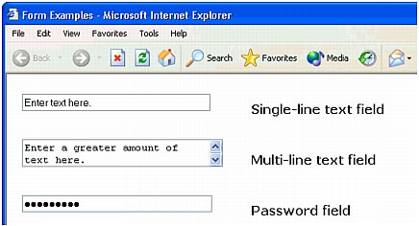
Note: Passwords and other information sent to a server using a password field are not encrypted. The transferred data can be intercepted and read as alphanumeric text. For this reason, you should always provide encryption for data you want to keep secure.
Hidden fields store information entered by a user, such as a name, e-mail address, or viewing preference, and then use that data when the user next visits the site.
Buttons perform actions when clicked. Typically these actions include submitting or resetting a form. You can add a custom name or label for a button, or use one of the predefined "Submit" or "Reset" labels.

Checkboxes allow multiple responses within a single group of options. A user can select as many options as apply. The example below illustrates this by showing three checkbox items selected: Surfing, Mountain Biking, and Rafting.
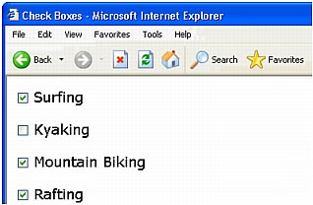

Radio buttons represent exclusive choices. Selecting a button within a radio button group deselects all others in the group (a group consists of two or more buttons that share the same name). In the example below, Rafting is the currently selected option. If the user clicks Surfing, the Rafting button is automatically cleared.
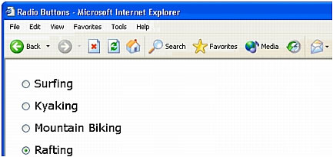

List/menus display option values within a scrolling list that allows users to select multiple options. The Menu option displays the option values in a menu that allows users to select only a single item.
Jump menus are navigational lists or pop-up menus that let you insert a menu in which each option links to a document or file.
File fields let users browse to a file on their computer and upload the file as form data.
Image fields let you insert an image in a form. Image fields can be used to make graphical buttons such as Submit or Reset buttons.

